Terminal Game - Create Hero Prototype

DESCRIPTION:
In this first kata in the series, you need to define a Hero prototype to be used in a terminal game. The hero should have the following attributes:
attribute | value
name | user argument or 'Hero'
position | '00'
health | 100
damage | 5
experience | 0

SOLUTION:
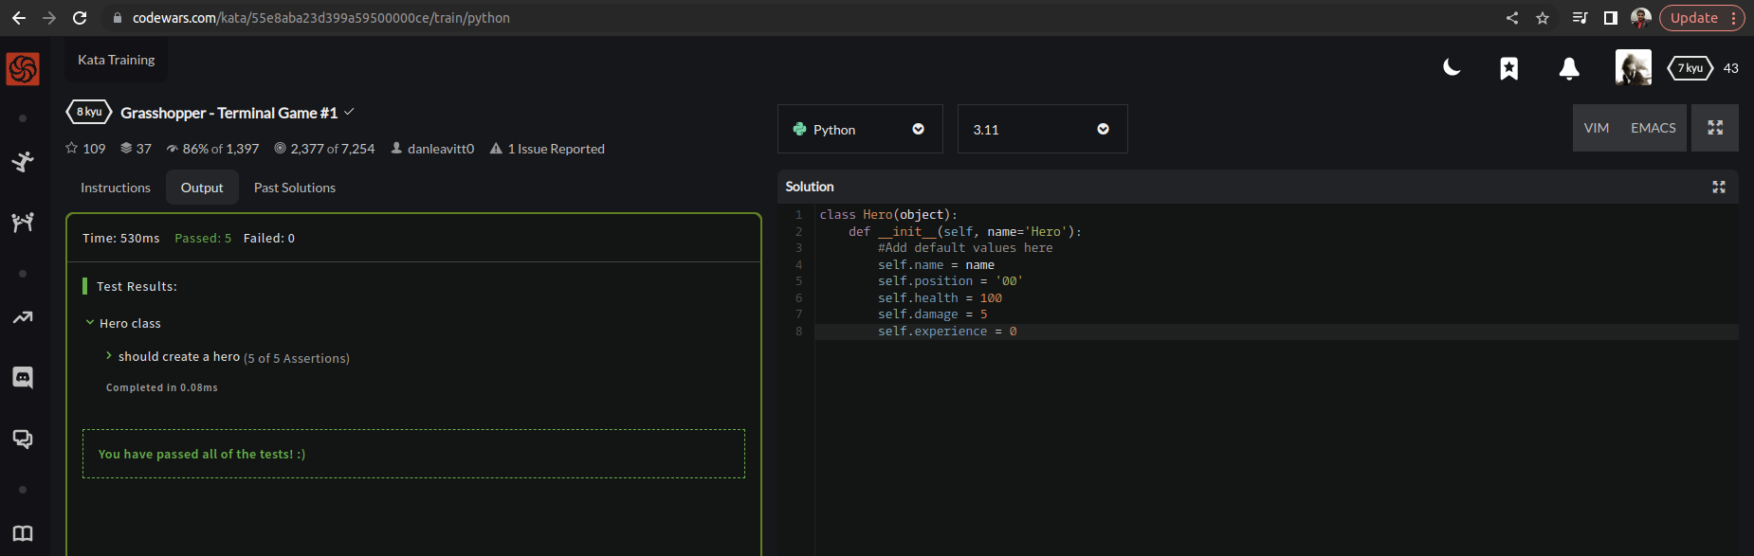

EXPLANATION:
This is a Python class called Hero, which represents a hero in a game. The class has an initializer method __init__ which takes one argument name, with a default value of 'Hero'.
name: a string representing the name of the hero. If no name is provided, the default value is 'Hero'.
- position: a string representing the current position of the hero. The default value is '00'.
- health: an integer representing the current health of the hero. The default value is 100.
- damage: an integer representing the damage done by the hero. The default value is 5.
- experience: an integer representing the experience gained by the hero. The default value is 0.

